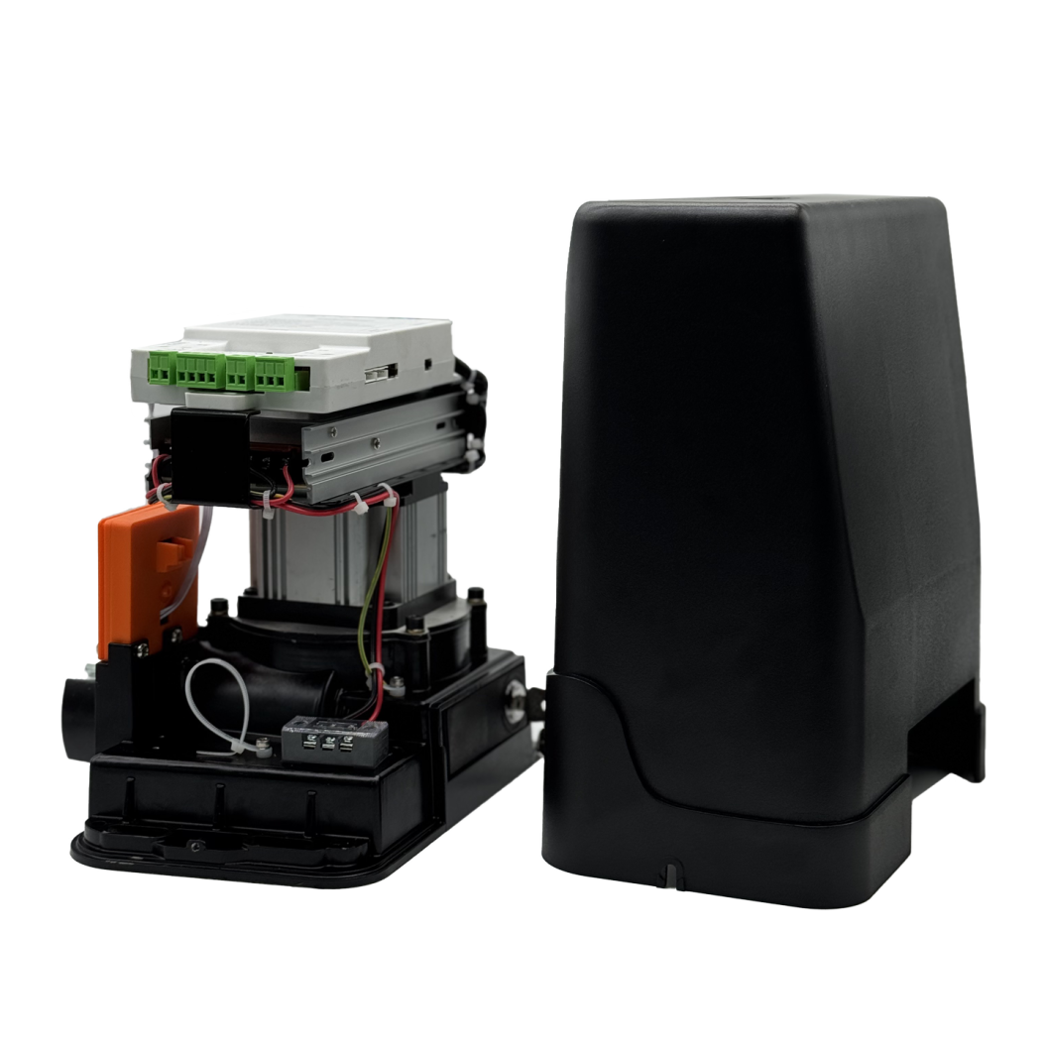
Specification of 28 Rack-and-Pinion Sliding Door Operator
Item | Parameter |  | Remark
Rated operating voltage | 24-36VDC
Motor operating voltage | 24VDC
Power | 200W | 400W
Operating current | 6A | 12A
Output torque of the worm reduction motor | ≥89Nm | ≥150Nm
Motor output rotation speed | 3000rpm
Running speed of operator | 0.2-0.3m/S
Matching door weight | 200W--≤1200KG | 400W--≤1800KG
Temperature rise | ≤15℃
Running noise | ≤60dB
Controller dimension | 219(W)*154(H)*52(H)mm
Dimension of worm reduction motor | 277.2(L)*130(W)*193.2(H)mm
Operating temperature | -35-70℃
Operating humidity | ≤95%，non-condensing

